A Randomized Clinical Study Comparing Reverse T-stenting and Minimal Protrusion with External Minicrush for treatment of complex coronary bifurcation (T-REX trial)

Principal Investigator Giulio Piedimonte MD
Interventional Cardiology Unit
ASLTO3 Rivoli Infermi Hospital (Rivoli) Turin, Italy
San Luigi Gonzaga University Hospital (Orbassano), Turin, Italy

Co-principal investigators

Ferdinando Varbella MD
Interventional Cardiology Unit
ASLTO3 Rivoli Infermi Hospital (Rivoli) Turin, Italy
San Luigi Gonzaga University Hospital (Orbassano), Turin, Italy

Enrico Cerrato MD, phD
Interventional Cardiology Unit
ASLTO3 Rivoli Infermi Hospital (Rivoli) Turin, Italy
San Luigi Gonzaga University Hospital (Orbassano), Turin, Italy

ABBREVIATIONS
PCI: Percutaneous Coronary Intervention
CCB: Complex Coronary Bifurcation
SB: Side Branch
MV: Main Vessel
KB: Kissing Ballon
ISR: Intrastent-Restenosis
ST: Stent thrombosis
TLF: Target Lesion Failure
TLR: Target Lesion Revascularization
CTO: Chronic Total Occlusion
POT: Proximal Optimization Technique
TAP: T stenting and Minimal Protrusion
PS: Provisional Stenting
iFR: Instantaneous Wave-free Ratio FFR: Fractional Flow Reserve
MLA: Minimal Lumen Area
MSA: Minimum Stent Area
ACS/CCS: Acute Coronary Syndrome/Chronic Coronary Syndrome

INDEX
I. INTRODUCTION
- 1.1 Epidemiology
- 1.2 Coronary Bifurcation Geometry

II. DEFINITIONS
- 2.1 Definition of a Complex Lesion Involving a Coronary Bifurcation
- 2.2 Definition and Classification of Restenosis

III. TREATMENT TECHNIQUES FOR SINGLE-STENT CORONARY BIFURCATIONS
- 3.1 Provisional Stenting
- 3.2 Procedural Steps of Provisional Stenting
- 3.3 Provisional Stenting and Subsequent Stent Implantation in the SB (1 to 2 Stents)

IV. TREATMENT TECHNIQUES FOR 2-STENT CORONARY BIFURCATIONS
- 4.1 Classic Crush
- 4.2 MiniCrush
- 4.3 Double Kissing-Crush (DK-Crush)
- 4.4 Inverted Culotte
- 4.5 Reverse T-stenting And Minimal Protrusion (Reverse-TAP)
- 4.6 V-stenting

V. OUTCOMES
- 5.1 Provisional Stenting vs. 2-stent Technique
- 5.2 Comparison of 2-Stent Techniques

VI. RATIONALE OF THE STUDY

VII. STUDY PLAN
- 7.1 Objectives
- 7.2 Study Design
- 7.3 Inclusion/Exclusion Criteria
- 7.4 Randomization
- 7.5 Procedural Steps of Reverse-TAP
- 7.6 Procedural Steps of External Minicrush
- 7.7 Endpoints
- 7.8 Population Sample Calculation

VIII. DEFINITION OF ENDPOINTS, DATA COLLECTION, AND FOLLOW-UP
- 8.1 Clinical Endpoints
- 8.2 Safety Endpoints
- 8.3 Procedural Endpoints
- 8.4 Data Collection
- 8.5 Follow-up

IX. MATERIALS AND METHODS
- 9.1 Coronary Angiography and Quantitative Coronary Analysis (QCA)
- 9.2 Functional Assessment
- 9.3 Intracoronary Imaging
- 9.4 Drug-Eluting Stents (DES)
- 9.5 Coronary CT
- 9.6 Statistical Analysis
- 9.7 Duration of the Study
- 9.8 Patient Withdrawal from the Study

X. ORGANIZATION OPF THE STUDY
- 10.1 Enrollment Centers
- 10.2 Core Lab and Clinical Events Committee (CEC)
- 10.3 Ethical Committee and Trial Approval
- 10.4 Patient Information and Informed Consent
- 10.5 Confidentiality and Patient Data Protection
- 10.6 Source Documents
- 10.7 Case Report Form (CRF)
- 10.8 Final Study Report
- 10.9 Collection and Management of Clinical Data
  - 10.9.1) Monitoring
  - 10.9.2) Management of Clinical Data
- 10.10 Publication Policy

XI. REFERENCES
XII. FIGURES
TREX study design: synopsis of the study
Title | A Randomized Clinical Study Comparing Reverse T-stenting and Minimal Protrusion with External Minicrush for treatment of complex coronary bifurcation (T-REX trial)
Background | - According to DEFINITION criteria, PCI of complex coronary bifurcation with up-front two stent techniques is associated with lower target vessel revascularization (TVR) compared to Provisional Stenting¹.  - The Double-Kissing Crush stenting (DK-Crush)² has been tested with the Culotte³ and the Classic Crush⁴ techniques in the unprotected left main disease (ULMD) and in no-ULMD setting, respectively, showing better clinical outcomes.  - However, due to its technical complexity and simultaneous improvement of the Classic Crush technique evolved in the External Minicrush⁵, it has meant that the latter has become the most used Technique in the clinical practice in treating complex coronary bifurcation.  - The DK-Crush technique has never been tested with the External Minicrush, leaving the operators to choose one or the other according to their experience and preferences.⁶  - The Reverse T-stenting And Minimal Protrusion (Reverse TAP) is an up-front two-stent technique that treats complex coronary bifurcation.⁷ Compared to crush techniques, it does not require crushing of the side branch stent but only minimal protrusion of the side branch stent before main vessel stenting.  - Nowadays, no studies compare the Reverse-TAP and the External Minicrush in treating complex coronary bifurcation, so eventually, procedural, clinical and safety differences remain unknown.  - The issue's importance is highlighted by higher rates of stent thrombosis (ST) and in-stent restenosis (ISR) of the two stent techniques compared to Provisional Stenting in treating coronary bifurcation⁸.  - Consequently, investigating the efficacy and safety differences between the techniques could improve the treatment of complex coronary bifurcation to reduce post-PCI TVR.
Objective | Evaluate the Reverse TAP technique's superiority over the External Minicrush Technique in treating complex coronary bifurcation.
Study design | Prospective, randomized, multicenter trial
Primary endpoint  1-year | - Target Lesion Failure (TLF) (Composite of cardiac death, non-fatal target-vessel MI, ischemia-driven target lesion revascularization (TLR) + Definite or probable ST+ ISR >50% at coronary angiography at 12 months.
Secondary endpoint  3 and 5-years | 1. Cardiac death + TVMI + ST  2. Cardiac death + TVMI + ST +TLR
Safely endpoint | - Acute closure of the side branch and periprocedural-MI  - Intraprocedural ST and periprocedural-MI  - Major bleeding (BARC 3 and 5)  - Technical success  - Procedural success
Procedural endpoint | - Cross-over between groups  - Timing of rewiring  - Number of guidewires used  - Amount of contrast medium used  - Procedural time;  - Fluoroscopic time;  - X-rays exposition.
Study population | ACS or CCS patients with complex coronary bifurcation lesions with the indication of PCI.
Sample size | 361 patients
Study centres | Multicenter worldwide
Study promoter | Investigator-initiated
Principal Investigator  Co-principal Investigators | Giulio Piedimonte, MD  Enrico Cerrato, MD, PhD  Ferdinando Varbella, MD
Core lab | Policlinico University of Ferrara – Prof. Gianluca Campo
Clinical Event Adjudication Committee | A blinded Clinical Event Adjudication Committee will adjudicate all events included in the study endpoints
Duration | Five years
Sponsor | None

I. INTRODUCTION

1.1 Epidemiology
Coronary bifurcation lesions represent 10-20% of the percutaneous coronary interventions (PCI)⁹, and along with chronic total occlusions (CTOs), they are the most complex coronary lesions for two main reasons:
- Risk of acute side branch (SB) closure.
- Increased long-term risk of thrombosis and ischemic events compared to standard lesions.

1.2 Coronary Bifurcation Geometry
The anatomy of coronary bifurcations is governed by the law of fractal geometry, defining the principles by which the coronary vessel divides into the main vessel (MV) and the SB¹⁰. The first principle follows Murray's Law, which describes the relationship between the diameters of the proximal MV segment (pMV), the distal MV segment (dMV), and the SB according to the equation D₁³ = D₂³ + D₃³. This concept is simplified by Finet's Law, in which the relationship between pMV, dMV, and SB is governed by the equation D1 = (D2 + D3) x 0.678 (Figure 1).
From a practical perspective, these principles express how the MV reduces its calibre after the origin of the SB and lays the foundation for one of the main phases of coronary bifurcation treatment, "proximal optimization treatment" (POT). POT involves optimizing the proximal portion of a stent chosen based on the dMV diameter by dilating it with a balloon according to the pMV diameter.
The geometry of coronary bifurcation not only affects the diameters of the MV and SB but also influences blood flow, resulting in different plaque distributions. At the bifurcation carina, coronary flow experiences high shear stress and oscillatory flow, unlike the MV and SB lateral walls, where low shear stress and the absence of oscillatory flow favour endothelial dysfunction. This is why coronary plaques mostly spare the bifurcation carina and involve the lateral walls of the MV and SB (Figure 2).
These principles define the three elements on which the analysis of coronary disease involving a bifurcation is based:
- Evaluation of pMV, dMV, and SB diameters.
- Distribution of coronary plaque at the bifurcation carina.
- Evaluation of the bifurcation angle between MV and SB (Figure 3).
Recognizing a "true" lesion involving a coronary bifurcation is based on analyzing these three elements. Identifying such a lesion is crucial due to the high risk of acute SB closure after MV stenting, favouring a two-stent initial treatment strategy.

II. DEFINITIONS

2.1 Definition of a Complex Lesion Involving a Coronary Bifurcation
A true lesion involving a coronary bifurcation is characterized by stenosis involving the ostium of a significant SB (usually with a diameter ≥ 2.0 mm). This is defined as a vessel whose compromise would lead to severe consequences in symptoms and regional ischemia, with probable loss of contractile function in the case of definitive compromise. Recently, the DEFINITION criteria have been proposed to predict this risk and define a Complex Coronary Bifurcation (CCB)¹¹. These criteria are defined as follows:
Major:
- Major Type 1 for the Left Main lesions:
  - The length of the SB lesion is> 10 mm.
  - Stenosis of the SB ostium > 70%.
- Major Type 2 for non-Left Main lesions:
  - The length of the SB lesion is> 10 mm.
  - Stenosis of the SB ostium > 90%.
Minor:
- Moderate or severe calcifications.
- Multiple SB lesions.
- Bifurcation angle <45° or >70°.
- MV diameter < 2.5 mm.
- MV lesion > 25 mm.
- Lesion containing thrombus.

A lesion involving the bifurcation is considered complex when it meets one major criterion (type 1 or type 2) + two minor criteria. The treatment of such lesions should be performed with a 2-stent technique upfront due to the high risk of SB closure¹.

2.2 Definition and Classification of Restenosis
Restenosis is defined as the re-occlusion of a previously implanted stent, angiographically classified into four groups according to Mehran¹²:
Pattern I: Focal
- IA: Focal due to a gap between two implanted stents.
- IB: Marginal focal.
- IC: Focal within the stent body.
- ID: Multifocal.
Patterns II, III, and IV: Diffuse
- II: Intrastent.
- III: Proliferative.
- IV: Occlusive.

III. TREATMENT TECHNIQUES FOR SINGLE-STENT CORONARY BIFURCATIONS

3.1 Provisional Stenting
Provisional stenting is a single-stent treatment technique for coronary bifurcation. It is the most commonly used method due to its simplicity. It involves stenting of the MV only, possibly switching to a two-stent technique (1 to 2 stents) in case of deteriorating flow or acute SB closure. Therefore, the crucial element determining the long-term effectiveness and safety of provisional stenting is MV stenting.¹³

3.2 Procedural Steps of Provisional Stenting

  - Wiring of the MV and SB: The insertion of an SB protection guide during provisional stenting is essential for several reasons, including opening the bifurcation carina, reducing the risk of acute closure, and facilitating re-access in case of SB occlusion after MV stenting. In the event of acute SB occlusion, the guide serves as a marker for rewiring with a third guide onto which a dilation balloon can be placed to reopen the SB. In case of multiple unsuccessful attempts to rewire with a third guide, the "jailed wire" in the SB still allows inserting a small dilation balloon to create space between the vessel wall and the stent, allowing SB reopening (jailed wire technique). In conclusion, inserting an SB protection guide during provisional stenting is mandatory, and typically, SB wiring is performed first to avoid excessive manipulation of the guide that could lead to entanglement with the MV guide.

  - Predilation of the MV and SB: MV predilation is at the operator's discretion; however, preparing the lesion for the subsequent stenting phase is recommended, facilitating both stent sizing and subsequent optimization. In contrast, SB predilation is not recommended due to the risk of SB dissection, which would necessitate an unplanned two-stent strategy.

  - Selection of stent size: This choice is based on the dMV diameter, as selecting the stent size based on the pMV diameter could result in choosing a larger stent than the dMV diameter, risking distal dissection. However, choosing the stent based on the dMV diameter poses a risk of malapposition at the pMV level, which must be corrected with proximal dilatation using POT.

  - Proximal Optimization Technique (POT): This step is essential to correct stent malapposition at the pMV level caused by stent sizing based on the dMV diameter. For this phase, a short balloon (6-8 mm) of the same diameter or slightly larger than the pMV is recommended, with particular attention to positioning the distal marker of the balloon at the bifurcation carina or slightly beyond it (Figure 4). The importance of POT is demonstrated in the COBIS II study¹⁴, where the failure to perform POT was associated with an increased risk of major adverse cardiovascular events (MACE) compared to the control group where it was performed.

  - SB Rewiring: This phase involves rewiring the SB after stent placement in the MV. Rewiring should be performed in the most distal cell of the stent, as subsequent mesh dilation would allow better coverage of the SB ostium in that position, unlike rewiring performed at the proximal mesh (Figure 5). There are two techniques for rewiring: the first is called the "guidewire exchange technique," which involves exchanging the SB guide with the MV guide, and the second uses a third guide that utilizes the jailed guide in the SB as a marker. Choosing one Technique over the other is at the operator's discretion.

  - Opening the meshes in favour of the SB: Opening the meshes in the SB is essential for optimizing SB coverage and facilitating the insertion of a stent into the SB in case of a need to switch to a two-stent technique. Opening the distal cell of the MV in favour of the SB with a dilation balloon inevitably causes distortion of the pMV, which must be corrected. Two techniques allow the opening of SB meshes while correcting pMV distortion, namely the "Kissing Balloon" and the "POT-side-POT" ¹⁶ technique. The first involves opening the meshes in favour of the SB using two balloons inflated simultaneously. In contrast, the second involves sequential inflation of the dilation balloons in the MV and SB. The PROPOT trial¹⁷ showed no difference between the two techniques; therefore, choosing one or the other is at the operator's discretion.

3.3 Provisional Stenting and Subsequent Stent Implantation in the SB (1 to 2 Stents)

The need to implant a second stent in the side branch (SB) can depend on three leading causes, which are a) worsening of blood flow after implantation of the stent in the main vessel (MV), b) SB dissection after opening the stent struts of the MV, and c) acute closure of the SB after MV stenting due to severe SB disease. In these cases, the advantage is the possibility of intervening in the SB by implanting a second stent through four techniques: T-stenting, T-stenting and minimal protrusion (TAP), Culotte, and Internal Minicrush (Figure 6).
The choice of the Technique should take into account two aspects⁶: 1) the bifurcation angle, as "T-shape" angles are better suited to T-stenting or TAP techniques, while "Y-shape" angles are better suited to techniques such as Internal Minicrush or Culotte; 2) the rewiring location, as a distal location that ensures optimal SB coverage would favour T-stenting, whereas a proximal location with inadequate SB coverage would favour techniques with greater "coverage" such as TAP, Internal Minicrush, or Culotte. Regardless of the chosen Technique, kissing balloon (KB) inflation (preceded by rewiring in the case of Internal Minicrush and Culotte) and the final proximal optimization technique (POT) are required to optimize the bifurcation's geometry. However, one of the limitations of these techniques compared to upfront 2-stent techniques is the reduced coverage of the SB ostium due to the smaller number of struts, especially in T and TAP techniques (Figure 7), with an increased risk of restenosis at the bifurcation carina and a consequent increase in the risk of target lesion revascularization (TLR).¹⁸

IV. TREATMENT TECHNIQUES FOR 2-STENT CORONARY BIFURCATIONS

4.1 Classical Crush
Proposed by Colombo et al.³, the Classical Crush initially involves steps 1 and 2 of Provisional Stenting (PS), as previously described, which are repeated for all two-stent treatment techniques for coronary bifurcations. Classical Crush involves placing the first stent in the SB with a proximal protrusion of at least 5 mm into the MV and crushing it using the stent inserted in it. Subsequently, steps 4, 5, and 6 of PS are repeated with the struts opening in favour of the SB using KBI.

4.2 Minicrush
Galassi et al.⁵ proposed that Minicrush has two substantial differences from Classical Crush. The first is the smaller proximal protrusion of the SB stent into the MV (not exceeding 2 mm), and the second is that the stent is crushed using a balloon inserted into the MV. Subsequently, the stent is inserted into the MV with the externally crushed SB stent (External Minicrush). A variant of this Technique is NanoCrush, which further reduces the protrusion of the SB stent into the MV to crush a minimal portion (nano) of the SB stent struts with a balloon inflated in the MV. In summary, the evolution of "Crush" techniques (Figure 8) is based on the progressive reduction of the SB stent protrusion into the MV and the consequent reduction in the extent of stent strut crushing to reduce the length of the triple-layer of struts at the bifurcation carina.²⁰
Another technique variant is used in the transition from PS to 2-stent treatment. In this case, the SB stent is inserted after the MV stent, and the SB stent is crushed internally to the MV stent (Internal or reverse Minicrush). Subsequently, steps 4, 5, and 6 of PS are repeated with the struts opening in favour of the SB using KBI. External Minicrush represents the most commonly used Technique in treating upfront 2-stent bifurcations due to its effectiveness, safety, and relative ease of execution.

4.3 Double-Kissing Crush (DK-Crush)
DK-Crush² represents an evolution of the Classic Crush previously described but differs significantly by including an initial KBI after placing the stent in the SB. This should allow better preparation and coverage of the SB ostium. The subsequent phases involve stent placement in the MV and a final KBI. The DK-Nanocrush²¹, on the other hand, is an evolution of DK-Crush and differs from the original Technique due to the smaller protrusion of the SB stent into the MV. In conclusion, the steps of DK-Crush are summarized in the following points:
- Stenting of the SB with minimal proximal protrusion into the MV.
- Crushing the SB stent with a balloon inserted into the MV.
- Proximal rewiring of the stent into the SB.
- First KBI.
- Insertion of the stent into the MV.
- Second rewiring.
- Second KBI.
- Final POT.
In DK-Crush, unlike PS, the first rewiring must occur in the proximal strut⁶ because distal rewiring would cause the stent struts to move away from the vessel wall with suboptimal SB ostium coverage.

4.4 Inverted Culotte
The Culotte was first described in 1998 by Chavelier et al.²² and, in its original description, can be considered an integral part of PS with subsequent stent implantation in the SB after step 6. In contrast, Inverted Culotte falls under the upfront 2-stent Technique and differs from the former by inserting the first stent into the SB. The subsequent steps are identical to those of the traditional Culotte. An improvement in this Technique is represented by the Double-Kissing Culotte (DK-Culotte)²³, which differs from the previous one by having a first KB as a step to open the stent struts in favour of the MV after inserting the stent into the SB. The concept is very similar to that of DK-Crush, where the first KB, compared to simple balloon dilation, should improve SB ostium coverage and ensure better reconstruction of the bifurcation carina.

4.5 Reverse T-stenting And Minimal Protrusion (Reverse-TAP)
Reverse-TAP was proposed in 2017 by Tsiafoutis et al.⁷ as a modification of the TAP technique starting from PS, usable as an upfront 2-stent technique. The procedural steps of the Technique are summarized below (Figure 9):
- Release in a kissing fashion of the SB stent, using a balloon inflated on the MV as a marker for minimal proximal protrusion of the SB stent into the MV.
- Insertion of the stent into the MV.
- POT.
- Proximal rewiring of the stent into the SB.
- KBI.
The main difference from Crush techniques is the reconstruction of the bifurcation carina without crushing the stent struts in the SB. This allows for avoiding three stent struts at the side vessel wall. Another difference is related to the fact that releasing the SB stent in a kissing fashion allows the proximal part of the stent to be open and with open cells, which could facilitate subsequent rewiring after inserting the stent into the MV. Furthermore, this technique avoids a procedural step of crush techniques that involves using a balloon in the MV to crush the stent placed in the SB. Therefore, this technique may facilitate the execution of a complex 2-stent technique in treating coronary bifurcations.

4.6 V-stenting
This Technique was first described in 1996 by Shampaert et al.²⁴, using a Palmaz-Schatz metallic stent pre-mounted on two balloons joined with adhesive in the proximal shaft. The technique was designed to simultaneously treat the confluence polygon's bifurcation with an ostial disease of the anterior descending and circumflex arteries. This Technique has been further improved with the advent of drug-eluting stents with separate delivery of the stents. It is still indicated in some selected cases of Left Main bifurcations according to the Medina classification 0.1.1. A variant of this Technique involves minimal proximal protrusion of both stents to ensure ostial involvement of the vessels with a "rifle barrel" reconstruction of the bifurcation carina (Simultaneous Kissing Stenting, SKS).²⁵

V. OUTCOMES

5.1 Provisional Stenting vs. 2-stent Technique
The initial studies on coronary bifurcations aimed to clarify whether a one-stent strategy could be equally effective compared to a two-stent strategy, with the advantage of providing less technical complexity and not precluding the possibility of treating the SB with a second stent. The randomized clinical trials conducted on this topic are summarized below:
- Colombo et al.²⁶ compared the rate of in-stent restenosis (ISR) after angiographic follow-up at 6 months between PS and 2-stent techniques [Classic Crush, Culotte, and T] (18.7% vs 28.0%; p=NS).
- Pan et al.²⁷ compared PS vs. T on the rate of ISR at 6 months after angiographic follow-up (7% vs. 25%; p=NS).
- Bifurcation Bad Krozingen Study (BBK I)²⁸ compared PS vs. T on the rate of ISR after angiographic follow-up at 9 months (23.0% vs. 23.7%; p=NS).
- CACTUS study²⁹ compared PS vs. Classical Crush on the rate of major adverse cardiovascular events (MACE) at 6 months (15% vs. 15.8%; p<0.05).
- DK-CRUSH II study³⁰ compared PS vs. DK-Crush in non-left main bifurcations on the rate of MACE at 12 months (17.3% vs. 10.3%; p=0.070).
- NORDIC study³¹ compared PS vs. 2-stent techniques [Classic Crush, Culotte, and T] on the rate of MACE at 6 months (2.9% vs. 3.4%; p=NS).
- DK-CRUSH V study¹⁸ compared PS vs. DK-Crush in left main bifurcations on the rate of MACE at 12 months (10.7% vs. 5.0%; p=0.02).
- BBC ONE study³² compared PS vs. 2-stent techniques [Classic Crush and Culotte] on the rate of MACE at 9 months (8% vs. 15.8%; p=NS).
- DEFINITION II study¹ compared PS and 2-stent techniques [DK-Crush and Culotte] on the rate of MACE at 12 months (11.4% vs. 6.1%; p=0.019).

PS has the advantage of being convertible to a 2-stent technique (Culotte, T-Stenting, TAP) in case of periprocedural compromise of the SB. However, the main limitations of PS emerge in the case of severe and extensive SB disease that meets the DEFINITION criteria¹, in which a relatively simple technique like PS seems to be less effective than upfront 2-stent techniques for treating complex disease. Furthermore, transitioning from one to two stents (1 to 2 stent technique) may not be associated with optimal bifurcation carina coverage compared to upfront 2-stent techniques, potentially resulting in suboptimal long-term outcomes.¹⁸
The Definition criteria are derived from the DEFINITION randomized trial¹¹ designed to distinguish simple bifurcations from complex coronary bifurcations, allowing treatment strategies to be differentiated based on the bifurcation's complexity. This study included patients with true bifurcations according to the Medina classification (1.1.1 and 0.1.1). From this study emerged the following anatomical factors that allow the classification of a true bifurcation as simple or complex:
- Major 1: Bifurcation of the left main coronary artery (LMCA) with SB disease >70% and length >10 mm (OR 55.2, 95% CI 21.005 to 79.437; p<0.001).
- Major 2: Epicardial bifurcations with SB disease >90% and length >10 mm (OR 66.3, 95% CI 12.708 to 98.184; p<0.001).
- Minor 1: Moderate or severe calcifications (OR 38.7, 95% CI 24.516 to 72.695; p=0.002).
- Minor 2: Multipole SB lesions (OR 26.8, 95% CI 4.332 to 57.004; p=0.007).
- Minor 3: Bifurcation angle <45° (OR 14.1, 95% CI 9.245 to 18.018; p=0.004).
- Minor 4: MV <2.5 mm (OR 9.4, 95% CI 7.556 to 14.814; p=0.010).
- Minor 5: Lesion containing thrombus (OR 27.2, 95% CI 4.662 to 78.301; p=0.002).
- Minor 6: Length of the lesion in the MV >25 mm (OR 6.9, 95% CI 3.879 to 12.398; p=0.010).

The presence of one major criterion + 2 minor criteria defines a true bifurcation as complex (CCB) with a specificity and sensitivity of 88% and 83%, respectively.
The non-uniform results regarding the superiority of 2-stent techniques vs. PS are related to the fact that many studies comparing PS and 2-stent techniques involved true but not complex bifurcations. In contrast, in the DEFINITION II trial¹, where the comparison was made only on CCB, PS showed all its limitations in treating complex pathology compared to upfront 2-stent techniques.

5.2 Comparison of 2-Stent Techniques
The randomized studies that compared the two-stent techniques are reported below:
• Bifurcation Bad Krozingen Study II (BBK II)³³ (300 pts) compared Culotte vs. TAP on the rate of ISR at 9 months after angiographic control (6.5% vs. 17%; p=0.006).
• DK-CRUSH I study³ (311 pts) compared Classical Crush vs DK-Crush on the rate of MACE at 8 months (24.4% vs 11.4%; p=0.02).
• DK-CRUSH III study⁴ (419 pts) compared Culotte vs. DK-Crush in Left Main bifurcations on the rate of MACE at 12 months (16.3% vs. 6.2%; p<0.05).

Different techniques for upfront two-stent treatment are often chosen at the operator's discretion. However, the best upfront two-stent treatment technique for treating bifurcation coronary lesions (BCC) remains largely uncertain. The DK-Crush is a two-stent technique that represents the evolution of crush techniques. The hypothetical advantage of this Technique is to ensure better optimization of the struts at the SB ostium through a double kissing (DK) approach. The effectiveness and safety of this technique have been evaluated in two randomized trials, one comparing it to the Classic Crush in non-left Main lesions³ and the other to Culotte in Left Main lesions⁴, showing an advantage in MACE at 12 months.
However, DK-Crush is a complex technique that requires numerous steps (at least 11) compared to the simplified and, unless proven otherwise, equally effective External Minicrush. For this reason, External Minicrush is the most widely used Technique in treating two-stent bifurcations. However, as of now, no randomized trials are comparing External Minicrush to other two-stent treatment techniques for CCB.

VI. RATIONALE OF THE STUDY

The Reverse-TAP treatment technique is a method described for upfront two-stent treatment of CCB. Like External Minicrush, it involves only one rewiring. Unlike it, it does not involve crushing the struts of the stent at the carina but only minimal protrusion (<2 mm) of the SB stent struts into the main vessel (MV). Furthermore, stent release via kissing balloon inflation allows for keeping the stent struts more open, potentially facilitating rewiring, unlike External Minicrush. Currently, for treating two-stent CCB, the TAP technique is recommended for angles >70°, while crush techniques are recommended for angles <45°.⁶ This recommendation is mainly based on expert opinion and is poorly followed in clinical practice, not considering that most bifurcation angles are between 45° and 70°. Given the lack of comparative data and the significant interest in this topic, there is currently an ongoing randomized protocol comparing Reverse TAP with DK-Crush in the treatment of CCB (TIP TAP trial)³⁴, with evaluation of soft endpoints such as stent expansion at the carina of the bifurcation.

VII. STUDY PLAN

7.1 Objectives
This study aims to assess the superiority of the Reverse-TAP technique in treating CCB in terms of effectiveness and safety compared to the External Minicrush technique.

Primary Objective
- Evaluate the effect of the two treatment techniques on the composite endpoint of target lesion failure (TLF) (Cardiovascular death, target vessel-related myocardial infarction, and clinically or objectively-driven target lesion revascularization (TLR)) + definite or probable stent thrombosis (ST) + ISR >50% identified at coronary angiography or coronary CT at 12 months.

Secondary Objectives
- Composite endpoint: Cardiovascular death + target vessel-related myocardial infarction + definite or probable ST at 5 years.
- Composite endpoint: Cardiovascular death + target vessel-related myocardial infarction + TLR at 5 years.

Safety Objectives
- Acute SB closure with consequent periprocedural myocardial infarction.
- Intraprocedural ST with consequent periprocedural myocardial infarction.
- Major bleeding.
- Technical success of the procedure.
- Procedural success.

Procedural Objectives
- Cross-over between the two groups.
- SB rewiring time after MV stent implantation.
- Total number of coronary guidewires used.
- Amount of contrast medium used.
- Total procedural time.
- Total fluoroscopy time.
- Total X-ray exposure.

7.2 Study Design
This is a multicenter, prospective, randomized study involving several European centres. Patients with an indication for PCI according to current guidelines with at least one complex coronary bifurcation lesion as defined by the Definition criteria will be invited to participate. PCI procedures will be performed via radial or femoral access as deemed appropriate by the operator and following local protocols. Intravascular imaging with IVUS or OCT will be strongly recommended for guiding revascularization, and the choice of drug-eluting stent type will be at the operator's discretion, considering the use of only second or third-generation drug-eluting stents. At 30 days, clinical follow-up will be conducted via telephone contact. At 6 months, through either direct clinical visit or telephone contact, and at 12 months, angiographic or coronary CT control will be performed to detect significant, prognostically relevant restenosis, defined at coronary angiography as lesions in the target site > 70% or > 50% and <70% functionally ischemic after evaluation using Fractional Flow Reserve (FFR) as per guidelines.³⁵ In patients undergoing coronary CT control with evidence of significant restenosis defined as a lesion in the target lesion site > 50%, angiographic control will be scheduled to determine severity according to previously defined criteria. In the case of symptomatic patients or clinical evidence of ischemia on noninvasive tests within 12 months of the index procedure, coronary angiography will be scheduled electively or urgently according to current CCS/ACS guidelines. If this event occurs more than 6 months after the index procedure, a 12-month cardiology follow-up visit will be scheduled without coronary angiography or CT.
All patients will be formally enrolled at the time of allocation to the treatment arm after randomization and subsequently examined for clinical outcomes. Randomization and treatment may be simultaneous or sequential (PCI before or after randomization) based on the patient's clinical presentation and the organizational needs of the participating centres. The clinical status from the index procedure, laboratory and instrumental tests, and all specific documentation (e.g., 12-lead ECG and medical therapy) will be carefully collected. Each clinical document will be recorded and examined in detail by a clinical event adjudication committee assessing every clinical event attributable to the target vessel and the bifurcation technique used.
All patients enrolled in the study must provide their consent by signing the informed consent form of the study protocol, including angiographic or coronary CT control at 12 months, clinical data management, and telephone/clinical visit contact during the study follow-up. The completeness and accuracy of CRF (Case Report Form) completion will be periodically verified in each enrolling centre to ensure <5% missing data for each variable. The study will follow the Declaration of Helsinki for ethical principles of medical research involving human subjects, and the coordinating centre will coordinate data management and final analyses.
This study can be conducted during the everyday activities of the interventional cardiology department. All described treatments are standard care for managing severe coronary disease in patients requiring PCI. Therefore, the study does not alter the normal daily operation of the hemodynamics lab and does not require any additional procedures specific to the patient for the study. No specific insurance is required to conduct this study since all treatment modalities are standard of care in patients with complex coronary bifurcations already scheduled for PCI.
Given the complexity of two-stent coronary angioplasties of coronary bifurcations, programmed angiographic control is the standard of care in such patients to detect prognostically relevant silent restenosis, even in asymptomatic patients. Restenosis is a complication of PCI that can have a negative prognostic impact even in clinically asymptomatic patients.³⁶ Moreover, in the case of the use of second-generation drug-eluting stents, the restenosis pattern is often mixed (proliferative and neo-atherosclerotic), which seems to be associated with a greater risk of destabilization in acute coronary syndrome compared to the more common proliferative restenosis in the case of non-drug-eluting metallic stents.³⁷ For this reason, our centre already performs scheduled angiographic control of complex angioplasties, such as those of the Left Main, as a standard of clinical practice, with the benefit of detecting silent but prognostically relevant restenosis in 10-20% of cases, as shown by data from our centre on approximately 1000 angiographic follow-ups of Left Main PCI (National Hospital Cardiologists Congress, ANMCO 2022).
Furthermore, our centre is one of the co-investigators of the PULSE trial, funded by the Finalized project (GR- 2016-02362546; https://clinicaltrials.gov/ct2/show/NCT04144881), in which coronary CT was tested for the follow-up of patients treated with PCI on the Left main bifurcation.
Finally, the clinical Monitoring of enrolled patients follows the current clinical practice of our centre, i.e., a telephone contact at 30 days, a direct clinical visit or telephone contact at 6 months, and an angiographic control or coronary CT at 12 months. Considering the medium to long-term evaluation, two telephone contacts at 3 and 5 years are planned, resulting in a total study duration of 5 years.

7.3 Inclusion/Exclusion Criteria
Patient enrollment will be prospective and sequential so that every patient with an indication for PCI and documented bifurcation coronary lesion can participate in the study and, therefore, be evaluated according to the selection criteria defined by the study protocol. Lesions involved in this trial must meet all inclusion criteria (listed below). Furthermore, if any exclusion criterion is present, the investigator must exclude the patient from enrollment in the trial.
Inclusion Criteria
- Patients >18 years of age.
- Patients with an indication for PCI, including chronic coronary syndrome and acute coronary syndromes (STEMI, NSTEMI, unstable angina).
- Patients with at least one true coronary bifurcation according to the Medina classification 1.1.1, 0.1.1, 1.0.1, 0.0.1, and complex according to the Definition criteria.
Exclusion Criteria
- Patients who do not want or cannot sign the informed consent for the procedure.
- Patients with severe peripheral vascular disease that limits vascular access to the point of making the procedure unsafe.
- Patients with a life expectancy of <1 year.
- Patients with planned major surgery require prolonged discontinuation of antiplatelet therapy.
- Pregnant women.
- Patients who cannot take antiplatelet therapy for any reason.

7.4 Randomization
After coronary angiography and identification of a lesion involving a CCB, patients will be randomized 1:1 to treatment with Reverse-TAP or External Minicrush. Randomization will be performed using an online computer system. Treatment can be either simultaneous or after randomization (pre-procedure or elective post-randomization) in accordance with the patient's clinical status and the organizational needs of the enrolling centres.

7.5 Procedural Steps of Reverse-TAP
The procedural phases of the Reverse-TAP technique follow the steps described in the original Technique by Tsiafoutis et al.⁷
Procedural Steps
- Wiring of the MV and the SB.
- Predilation of the MV and the SB.
- Stenting of the SB with minimal protrusion into the MV and simultaneous inflation of a balloon in the MV (KBI release).
- Second KBI with minimal retraction of the SB stent balloon into the MV.
- Stenting of the MV.
- POT.
- Rewiring of the SB and FKBI.

7.6 Procedural Steps of External Minicrush
The procedural phases of the External Minicrush technique follow the steps described in the original Technique by Galassi et al.⁵
Procedural Steps
- Wiring of the MV and the SB.
- Predilation of the MV and the SB.
- Advancement of a dilatation balloon into the MV at the ostium of the SB.
- Stenting of the SB with minimal protrusion into the MV (<5 mm).
- Advancement and inflation of a dilatation balloon into the MV to achieve crushing of the SB stent struts.
- Stenting of the MV.
- POT.
- Rewiring of the SB and FKBI.

7.7 Endpoints
Primary Endpoint
- Failure of the target lesion (TLF) (Cardiovascular death, target vessel-related myocardial infarction, clinically or objectively-driven target lesion revascularization (TLR)) + definite or probable stent thrombosis (ST) + ISR >50% at coronary angiography or coronary CT at 12 months.

Secondary Endpoints
- Composite endpoint: Cardiovascular death + target vessel-related myocardial infarction + definite or probable ST at 5 years.
- Composite endpoint: Cardiovascular death + target vessel-related myocardial infarction + TLR at 5 years.

Safety Endpoints
- Acute SB closure with consequent periprocedural myocardial infarction.
- Intraprocedural ST with consequent periprocedural myocardial infarction.
- Major bleeding.
- Technical success.
- Procedural success.

Procedural Endpoints
- Cross-over between the two groups.
- SB rewiring time after MV stent implantation.
- Total number of coronary guidewires used.
- Amount of contrast medium used.
- Total procedural time.
- Total fluoroscopy time.
- Total X-ray exposure.

7.8 Population Sample Calculation
Based on previous studies on treating coronary bifurcations with 2-stent techniques, a cumulative incidence of 24.4% for the primary endpoint is expected in the group treated with the Minicrush technique. In contrast, a cumulative incidence for the Reverse TAP technique is expected for the primary endpoint of 12%. Therefore, a sample of 316 patients (158 per group) will provide a statistical power of 80% for a superiority test to identify, with a significance level of 5%, a 50% reduction in the expected primary outcome measurement in the experimental group (Reverse-TAP) compared to the control group (External minicrush). Considering an estimated cross-over between the two groups of 2% and a 5% drop-out rate, a total sample of 361 patients will be required to conduct the study. After the first 50 enrolled patients, an interim analysis is planned to assess any adjustments to the population sample, considering the lack of existing literature data comparing the two treatment techniques.
Population Sample Calculation for Superiority:
n=f( 𝛼/2, ß) x [p1 x (100-p1) + p2 x (100 -p2)] / (p2-p1)2

VIII. DEFINITION OF ENDPOINTS, DATA COLLECTION, AND FOLLOW-UP

8.1 Clinical Endpoints
Mortality from all causes includes cardiac death and non-cardiac death, documented through access to medical records or death certificates. Cardiac death is defined as any death related to a cardiac cause, including heart failure, myocardial infarction, arrhythmias, and sudden cardiac death.³⁸ Myocardial infarction related to the target lesion is defined as an increase, >48 hours after the index procedure, in the levels of myocardial necrosis markers CK-MB or high-sensitivity Troponin above the normal value³⁹ (according to local laboratory ranges) in association with at least one of the following parameters: 1) symptoms of acute ischemia; 2) new onset of ST-segment elevation or T-wave changes in leads related to the target vessel or the onset of a left bundle branch block; 3) development of pathological Q-waves in leads exploring the target vessel; 4) evidence on noninvasive imaging tests (scintigraphy or magnetic resonance) of non-viable myocardial zones corresponding to the target vessel's distribution territory; 5) evidence of intracoronary thrombotic lesion in the target vessel at coronary angiography or autopsy.⁴⁰ Revascularization of the target lesion guided by clinical, anatomical, or objective documentation of ischemia (TLR) includes any type of revascularization (PCI or CABG) following the recurrence of angina symptoms or equivalent, significant lesions on coronary angiography, and signs of ischemia (exercise stress test, myocardial scintigraphy, stress echocardiography, stress cardiac magnetic resonance, functionally ischemic lesions on coronary angiography). After coronary angiography, significant restenosis is defined as restenosis at the target bifurcation site >70% or >50% and <70% ischemic after functional evaluation using iFR or FFR methods or in the presence of objective ischemia on noninvasive tests (myocardial scintigraphy, stress echocardiography, or stress cardiac magnetic resonance).

8.2 Safety Endpoints
Acute closure of the SB is defined as the sudden appearance of TIMI 0 flow in the SB at any procedural stage of treatment in SB with TIMI 3 baseline flow. In these patients, the occurrence of periprocedural myocardial infarction will be defined as an increase in myocardial necrosis enzymes CK-MB >5 times or Troponin HS >35 times the normal value (according to local laboratory ranges) associated with at least one of the following features: 1) ischemic symptoms; 2) appearance of ST-segment alterations, T-wave changes, or left bundle branch block; 3) development of Q-waves of necrosis in the territory of the SB; 4) evidence on noninvasive imaging tests (scintigraphy or magnetic resonance) of non-viable myocardial zones corresponding to the SB distribution territory. Periprocedural infarction will be defined based on only myocardial necrosis enzymes in the case of CK-MB >10 times or Troponin HS >70 times the normal value.⁴⁰
The Academic Research Consortium document defines stent thrombosis as definite or probable.⁴² Major bleeding is defined according to the Bleeding Academic Research Consortium (BARC)⁴³ classification and will consider bleeding of types 3 and 5:
• Type 3a: documented bleeding with a decrease in hemoglobin >3 g/dL and <5 g/dL;
• Type 3b: any bleeding requiring at least one red blood cell transfusion;
• Type 3c: intracranial bleeding;
• Type 5a: non-confirmed fatal bleeding at autopsy or imaging;
• Type 5b: confirmed fatal bleeding at autopsy or imaging.
Technical success is defined as residual stenosis <20% at the bifurcation site, TIMI 3 flow on both MV and SB, and absence of intraprocedural stent thrombosis, acute SB closure, and periprocedural myocardial infarction. Procedural success is defined by technical success and the absence of TLF, TLR, ST, and ISR >50% at 12 months.⁴⁴

8.3 Procedural Endpoints
Cross-over: Based on randomization, cross-over will be considered when a different technique than the one planned is used. Cross-over may also involve techniques not included in the study (e.g., Culotte, DK-Crush). It will be considered cross-over from the Reverse-TAP group to the External Minicrush group if an inflated balloon in the MV is used to crush the protruding SB stent into the MV; vice versa, it will be considered cross-over from the External Minicrush group to the Reverse-TAP group if an inflated balloon in the MV is not used to crush the protruding SB stent into the MV.
Time spent in rewiring: the time from the guide's exit from the guide catheter to rewiring the SB stent loops until reaching the most distal position of the SB.
Total number of coronary guides used: any guide used for bifurcation PCI will be counted.
Amount of contrast medium used: the total amount of contrast medium used to complete the procedure, expressed in millilitres.
Total procedural time: the time from arterial sheath insertion to target vessel cannulation at the end of the procedure, expressed in minutes.
Total fluoroscopy time: total time of fluoroscopy use, expressed in minutes.
Radiation exposure: total radiation exposure, expressed in mGy*cm^2.

8.4 Data Collection
The study will be conducted following European regulation ISO 14155 parts 1 and 2 (2009) and Good Clinical Practice (GCP). The rights of patients will be guaranteed throughout the trial following the most recent version of the Helsinki Declaration. The trial protocol requires the investigator to thoroughly evaluate the patient before enrollment. The investigator is also responsible for assessing the patient's clinical status and scheduling follow-up: two phone contacts at 30 days and 6 months must be scheduled to verify the patient's clinical status and any occurrence of clinical events. The centre may be accessible to perform the 6-month follow-up through telephone contact or direct clinical visits. Patient data must be collected at the time of enrollment and during clinical follow-up and includes:
• Demographic data.
• Clinical examination, including assessing major cardiovascular risk factors, internal medicine, and cardiological history. A clinical reevaluation should be performed during follow-up contacts or in case of new hospitalization for adverse events.
• Hematochemical tests: haemoglobin, platelet count, creatinine, liver function (AST/ALT), lipid profile (total cholesterol, HDL, LDL, triglycerides), plasma glucose, and myocardial necrosis enzymes including at least one of Troponin HS, CK-MB, and CK according to the enrolling centre. In case of new hospitalization for adverse events, enzymatic assays are required and should be collected.
• Electrocardiogram (ECG): a 12-lead electrocardiogram should be performed and collected during index procedure hospitalization and repeated during the 6-month clinical visit and in case of new hospitalization for adverse events.
• Coronary angiography or coronary CT angiography planned at 12 months: all patients will undergo a scheduled coronary angiographic or coronary CT angiographic control at 12 months to detect prognostically relevant and clinically silent restenosis in the case of complex angioplasty such as those involving TC and BCC. Any coronary angiography or coronary CT angiography should be collected to perform a thorough assessment of clinical endpoints, whether scheduled or not. It is essential and mandatory that all angiographic or coronary CT angiographic checks be performed under standard conditions and with a reproducible method to provide usable images for subsequent remote reevaluation. The angiographic examination and coronary CT angiography should follow the recommendations provided by the core lab identified in the study.

8.5 Follow-up
During follow-up, all patients will undergo a telephone interview at 30 days, telephone contact or direct visit at 6 months, and control through angiography, coronary CT angiography, or angiography at 12 months to evaluate clinical endpoints. Patients will undergo telephone contact at 24, 36, and 72 months from the index procedure to assess clinical status, therapeutic regimen, and any cardiovascular events at 5 years. In the case of unscheduled coronary angiography, the examination will be used to assess vessel and target site patency. All patients must adhere to telephone contacts and scheduled visits unless they withdraw their consent from the study or have deceased. The reasons for non-adherence to follow-up must be documented in the CRF. The date of the index procedure is considered day 0, and during follow-up, the following information should be collected:
• Clinical status assessment.
• Adverse cardiovascular events.
• Assessment of the therapeutic regimen (focusing on dual antiplatelet therapy). All patients enrolled in the study will be followed up for 5 years.

IX. MATERIALS AND METHODS
9.1 Coronary Angiography and Quantitative Coronary Analysis (QCA)
Angiographic images will be collected according to validated standards: the diagnostic examination should be performed to identify the presence of atherosclerotic lesions or restenosis in at least two different projections. Evaluation by QCA is not mandatory but strongly encouraged in case of doubtful lesions.

9.2 Functional Assessment
According to current guidelines for myocardial revascularisation, the evaluation by iFR/FFR of lesions at the target site (stenosis or restenosis) should occur for all lesions >50% and <70%. For FFR, induction of hyperemia should occur through intravenous adenosine infusion, following the clinical practice of each enrolling centre. Lesions eligible for PCI should have the following characteristics: iFR ≤ 0.89⁴¹ or FFR ≥ 0.80⁴⁵. All lesions that meet these values should undergo FFR-guided PCI. PCI should be performed in such cases to achieve post-stenting iFR and FFR ≥0.95 and ≥0.86, respectively. Further stent dilatation should be performed if these target values are not reached. If the target values are still not achieved, a pull-back should be performed to identify a possible drop worthy of further DES implantation. However, the trial protocol does not obligate performing a post-PCI FFR assessment.

9.3 Intracoronary Imaging
Intracoronary imaging is not mandatory in the study but is strongly recommended. The choice of the type of intracoronary imaging, whether OCT or IVUS, is at the operator's discretion. If the method is used, the ULTIMATE and CLI-OPCI criteria will be considered to define the MV and SB PCI results, respectively, for IVUS and OCT.
ULTIMATE Criteria⁴⁶:
• MSA > 5.0 mm2.
• Burden of plaque within 5 mm distal and proximal to the stent <50%.
• Absence of residual dissections at the edges.
The presence of 3 out of 3 criteria was defined as "optimal apposition," while the absence of only 1 of the 3 criteria defined the implantation as "suboptimal apposition."
CLI-OPCI Criteria⁴⁷:
• MSA > 4.5 mm2
• MSA >90% of the MLA

9.4 Drug-Eluting Stents (DES)
PCI should be performed using 2nd or 3rd generation DES, which is at the operator's discretion. The use of drug-eluting stents with absorbable scaffolds (BVS), 1st generation drug-eluting stents, non-drug-eluting metallic stents (BMS), drug-eluting stents dedicated to the treatment of bifurcations (e.g., Bioss Lim C), and the use of self-expanding nitinol stents for coronary purposes (e.g., Stentys XPosition S) is not allowed.

9.5 Coronary CT
Coronary CT angiography should be performed according to the standard protocols of the enrolling centre. All coronary arteries and major bifurcation branches should be reconstructed and analyzed. All images should be sent to a central core lab. The presence of restenosis at the bifurcation treatment site should be carefully evaluated. Images should be analyzed in the individual centre. In the case of significant restenosis, defined as >50% narrowing at the target lesion site, coronary angiography should be arranged to confirm its presence and assess its severity using anatomical or functional criteria through FFR.

9.6 Statistical Analysis
Dr. Giulio Piedimonte and Dr. Enrico Cerrato will perform statistical analysis. Qualitative variables will be expressed as numbers and percentages. In contrast, quantitative variables will be expressed as mean and standard deviation (SD) or median and interquartile range [25th-75th percentile], depending on their distribution. Normality will be assessed using the Kolmogorov-Smirnov test. Differences between quantitative variables between the two groups will be tested using the Student's t-test, Mann-Whitney test, or Wilcoxon test, depending on their distribution. Qualitative variables will be analyzed using the χ2 or Fisher's exact test. Survival analysis will be performed for secondary endpoint components using the Kaplan-Meier test and/or Cox regression analysis. A multivariate logistic model will be used to investigate independent primary endpoint predictors and calculate their relative risk (Hazard Ratio, HR) with associated 95% confidence intervals (CI). An error of the 1st type < 0.05 (p-value) is considered statistically significant for all tests. All statistical tests were performed using SPSS software (SPSS Inc., Chicago, Illinois, USA).

9.7 Duration of the Study
The enrollment phase of the study will end when a total of 361 patients are enrolled. Each participating centre should ensure that every enrolled patient is followed up in the follow-up phase. The follow-up includes a telephone contact at 30 days, a telephone contact or a scheduled visit at 6 months, a control through coronary angiography or coronary CT angiography or angiography at 12 months, and a telephone contact at 2, 3, and 5 years. In an event requiring unscheduled coronary angiography before 12 months and after 6 months from the index procedure, no coronary angiography or coronary CT angiography will be repeated at that time, but a cardiological visit will be performed. Each participating centre must meticulously plan all these evaluations. If the subject cannot be traced, and follow-up cannot be performed, the patient should be considered lost to follow-up and not included in the final analyses.

9.8 Patient Withdrawal from the Study
Each patient may withdraw from the study at any time and for any reason. Each patient should be encouraged to remain in the study until completing at least 1 year of follow-up. If the patient discontinues follow-up prematurely, a final patient evaluation should be completed, and the reason for study withdrawal should be documented. Patients who withdraw cannot be replaced during the study. A patient's participation in the study will be considered complete if the patient completes at least 1 year of follow-up.

X. ORGANIZATION OF THE STUDY

10.1) Enrollment Centers
This multicenter clinical study will include Interventional Cardiology centres with a documented and consolidated clinical experience in PCI (Percutaneous Coronary Intervention). The selection of investigational centres will be conducted considering the ability of these centres to meet the following requirements:
- Adequate catchment area to meet the study's inclusion criteria.
- Sufficient human and financial resources to support the study.
- Experience treating Coronary Bifurcation Lesions (CCB) through PCI using the most recent data from the Italian and European Society of Interventional Cardiology (GISE and euroPCR).
- The commitment to ensure the accuracy, legality, and safety of all study data.
- The ability to strictly follow the study protocol without any deviations, with accurate data entry in a reasonable time for study analyses.

10.2) Core Lab and Clinical Events Committee (CEC)
All coronary angiographies, coronary CT scans, and any intracoronary imaging acquisitions will be analyzed at a centralized core lab. The Clinical Events Committee (CEC) will be an independent evaluation body that does not include cardiologists or interventional cardiologists who are not involved in the clinical investigation. Based on study definitions, the CEC will blindly adjudicate all primary and secondary endpoint events. The CEC will not have access to the randomization strategy to avoid bias, an essential process in single-blind trials. The CEC will be responsible for reviewing and assessing all deaths or cases of spontaneous myocardial infarction that may occur during the trial. All sudden or unexpected deaths will be considered cardiac if no recognizable cause of death can be established; similarly, each spontaneous myocardial infarction will be attributed to the vessel and target lesion if the event cannot be linked to a non-target vessel.

10.3) Ethical Committee and Trial Approval
The study will be submitted for approval to the individual ethical committees affiliated with the participating centres.

10.4) Patient Information and Informed Consent
Informed consent for the study is mandatory for participation and must be obtained from all patients or their legal representatives. The investigator must inform each enrolled subject, providing detailed information about the nature of the study, its objectives, the technical characteristics of the proposed treatments, potential benefits of participating in the study, the study's duration, the approximate number of subjects involved, and the personal responsibility of the participating subject. Additionally, study participants must be informed that:
- Participation in the study is voluntary, and the patient may withdraw from the study at any time and for any reason. And withdrawing informed consent will not affect their subsequent medical treatment and relationship with their treating physician.
- Any circumstances or reasons for the patient's decision to withdraw from the study must be determined and documented.

10.5) Confidentiality and Patient Data Protection
All information and data concerning study participants will be considered confidential. Only those actively involved in the study, the ethics committee and regulatory authorities will have access to sensitive data and other documents to verify study procedures and data without violating the confidentiality of participating patients. All data used in analyses and reported in the manuscript will not be traceable to individual study participants.

10.6) Source Documents
Source documents represent the original documents of the patients involved in the study, including medical records, operative records, identification of the list of enrolled patients, operative reports, therapeutic charts of individual patients, data recorded by automatic devices during clinical Monitoring, any magnetic, electronic files, and X-rays, and hematologic and chemical tests. Each investigator must maintain and preserve the source documents of each study participant from their centre.

10.7) Case Report Form (CRF)
Electronic CRFs will be used to collect all patient data during the study. The investigator must complete and make their CRFs accurate. The investigator must review and correct CRFs with incomplete or inaccurate data. The CRF will have approximately the following structure:

- Enrollment phase (CRF 1): Section concerning demographic data, including clinical status, past medical history, home pharmacological treatment, cardiovascular risk factors, diagnostic angiography, and intraprocedural characteristics of PCI.
- Follow-up (CRF 2): Section concerning the patient's clinical status and pharmacological treatment during scheduled telephone/clinical visits or any other visits conducted outside of scheduled ones.
- Adverse events (CRF 3): Section concerning the registration of any adverse events and treatments performed by the patient (e.g., re-PCI, CABG) throughout the study period.

10.8) Final Study Report
After the completion or termination of the study, the principal investigator must submit a final study report to the ethics committee, including the obtained results. The report must be submitted to the ethics committee within 12 months of the completion or termination of the study.

10.9) Collection and Management of Clinical Data
10.9.1) Monitoring
Initial contact between the sponsoring centre and the participating centres of the study will be ensured to verify that the investigator clearly understands and accepts the obligations involved in the clinical investigation as outlined in ICH-GCP, ISO 14155-1 (2009). The sponsoring centre will ensure proper Monitoring, including the review of CRFs, verification of data sources, and the verification of obtaining informed consent. Periodic visits will be conducted at participating centres to ensure that investigators follow the obligations outlined in ICH-GCP and ISO 14155-1 (2009). Contacts between the monitor and investigators will be maintained throughout the study, and the monitor may meet with investigators at their respective enrollment centres.

10.9.2) Management of Clinical Data
Clinical data will be obtained during the study period and must be collected in the provided electronic CRFs by the sponsoring centre. Considering the collection of missing or inconsistent data, the principal investigator will request clarification of these data through Data Clarification Forms (DCFs) uploaded explicitly to the electronic database. The entire process of clinical data handling (from data collection to final statistical analyses) will follow internal procedural standards following European regulation ISO 14155 (2009).

10.10 Publication Policy
Principal investigators from the sponsoring centre must publish and disseminate the study results. The principal investigators from the sponsoring centre will carry out the manuscript writing. Since the study's outcome will result from the collective efforts of all recruiting centres, all investigators will be included in the authorship in advance based on the number of enrolled patients. The final number of authors will be determined following the regulations of the scientific journal that accepts the publication of the work.

XI. REFERENCES

- Zhang, J. et al. Interventional cardiology Multicentre, randomized comparison of two-stent and provisional stenting techniques in patients with complex coronary bifurcation lesions : the DEFINITION II trial. 2523–2536 (2020). doi:10.1093/eurheartj/ehaa543
- Hall, A. B. et al. Double kissing crush bifurcation stenting: step-by-step troubleshooting.

EuroIntervention 17, e317–e325 (20AD).

- S. L. Chen*, J. J. Zhang*, F. Ye*, Y. D. Chen†, T. Patel‡, K. Kawajiri§, M. Lee¶, T. W. Kwan**,

G. M. and H. C. T. Study comparing the double kissing (DK) crush with classical Crush for the treatment of coronary bifurcation lesions: the DKCRUSH-1 Bifurcation Study with drug-eluting stents. (2008). doi:Eur J Clin Invest 2008; 38 (6): 361–371
- From, R., Jiang, T., Wang, Y., Chen, F. & Yuan, Z. Comparison of Double Kissing Crush Versus Culotte Stenting for Unprotected Distal Left Main Bifurcation Lesions. J. Am. Coll. Cardiol. 61, 1482–1488 (2013).
- Galassi, A. R. et al. Long-term Outcomes of Bifurcation Lesions After Implantation of Drug- Eluting Stents With the '"Mini-Crush Technique"'. 983, 976–983 (2007).
- Lassen, J. F. et al. Treatment of coronary bifurcation lesions, part II: implanting two stents. The 16th expert consensus document of the European Bifurcation Club. EuroIntervention 18, 457–470 (19AD).
- Ioannis Tsiafoutis, MD, PhD; Theodoros Zografos, MD, PhD; Athanasios Antonakopoulos, MD, Ms. & Michael Koutouzis, MD, PhD; Grigorios Tsigkas, MD, PhD; Nikolaos Bourboulis, MD, PhD;Apostolos Katsivas, MD, P. The Reverse T-Stenting and Small Protrusion Technique: A Novel Technique for Coronary Bifurcation Lesions. (2017). doi:J INVASIVE CARDIOL 2017;29(12):E195-E196.

- Iakovou, I. et al. Incidence, predictors, and outcome of thrombosis after successful implantation of drug-eluting stents. JAMA 293, 2126–2130 (2005).
- Hildick-Smith, D., Arunothayaraj, S., Stankovic, G. & Chen, S.-L. Percutaneous coronary intervention of bifurcation lesions. EuroIntervention 18, e273–e291 (22AD).
- Milasinovic, D., Wijns, W. & Ntsekhe, M. Step-by-step manual for planning and performing bifurcation PCI : a resource-tailored approach. 1804–1811 (1804).
- Wang, Y., Chen, L., Tian, N., Cao, F. & Qiu, C. Impact of the Complexity of Bifurcation Lesions Treated With Drug-Eluting Stents. 7, 1266–1276 (2014).
- Mehran, R. et al. Classification and Implications for Long-Term Outcome. 1872–1878 (1999).

- Sawaya, F. J. et al. Contemporary Approach to Coronary&nbsp;Bifurcation Lesion Treatment.

JACC Cardiovasc. Interv. 9, 1861–1878 (2016).

- Yu, C. W. et al. Long-Term Clinical Outcomes of Final Kissing Ballooning in Coronary Bifurcation Lesions Treated With the 1-Stent Technique: Results From the COBIS II Registry (Korean Coronary Bifurcation Stenting Registry). JACC. Cardiovasc. Interv. 8, 1297–1307 (2015).
- Albiero, R. et al. Treatment of coronary bifurcation lesions, part I: implanting the first stent in the provisional pathway. The 16th expert consensus document of the European Bifurcation Club. EuroIntervention 18, e362–e376 (5AD).
- Dérimay, F. et al. Benefit of a new provisional stenting strategy , the re-proximal optimization technique : the rePOT clinical study. 325–332 (2018).
- Yusuke Watanabe, M.D, PhD; Yoshinobu Murasato, M.D, P. M. et al. Proximal Optimisation Technique Versus Final Kissing Balloon Inflation in Coronary Bifurcation Lesions: the Randomised, Multicenter PROPOT Trial. (2021). doi:10.4244/EIJ-D-20-01386
- Investigations, O. Double Kissing Crush Versus Provisional Stenting for Left Main Distal

Bifurcation Lesions. 70, 2605–2617 (2017).

- Ray, S., Mukherjee, P. & Bandyopadhyay, S. A novel "nano-crush" technique for the management of coronary bifurcation lesions : in vitro bench test analysis and preliminary report on real-world clinical evaluation in patients with one-year angiographic follow-up American College of Cardiology. 41–51 (2019).
- E., R. C. et al. Evolution of the Crush Technique for Bifurcation Stenting. JACC Cardiovasc.

Interv. 14, 2315–2326 (2021).

- Morris, P. D. et al. Double-Kissing Nanocrush for Bifurcation Lesions: Development, Bioengineering, Fluid Dynamics, and Initial Clinical Testing. Can. J. Cardiol. 36, 852–859 (2020).
- Chevalier, B. & Glatt, B. Placement of Coronary Stents in Bifurcation Lesions by the “ Culotte ” Technique. 9149, 943–949
- Gabor G. Toth, MD, PhD; Viktor Sasi, MD, PhD; Danilo Franco, MD; Anton J. Prassl, P., Luigi Di Serafino, MD, PhD; Jaryl C.K. Ng, PhD; Gyula Szanto, MD, P., Laura Schneller, RN; Hui Ying Ang, , PhD; Gernot Plank4, PhD; William Wijns, MD, P. & Emanuele Barbato, MD, P. Double-kissing culotte technique for coronary bifurcation stenting. (2020). doi:DOI: 10.4244/EIJ- D-20-00130
- Schampaert, E., Fort, S., Adelman, A. G. & Schwartz, L. The V-Stent : A Novel Technique for Coronary Bifurcation Stent i ng. 326, 320–326 (1996).
- Sharma, S. K. et al. Simultaneous Kissing Stents ( SKS ) Technique for Treating Bifurcation Lesions in Medium-to-Large Size Coronary Arteries. 195–199 (2004). doi:10.1016/j.amjcard.2004.06.027
- Colombo, A. et al. Randomized study to evaluate sirolimus-eluting stents implanted at coronary bifurcation lesions. Circulation 109, 1244–1249 (2004).

- Pan, M. et al. Rapamycin-eluting stents for the treatment of bifurcated coronary lesions: a randomized comparison of a simple versus complex strategy. Am. Heart J. 148, 857–864 (2004).
- Ferenc, M. et al. Interventional cardiology Randomized trial on routine vs . provisional T-stenting in the treatment of de novo coronary bifurcation lesions. 2859–2867 (2008). doi:10.1093/eurheartj/ehn455
- Lettieri, C., Zanini, R., Sheiban, I. & Paloscia, L. Randomized Study of the Crush Technique Versus Provisional Side-Branch Stenting in True The CACTUS ( Coronary Bifurcations : Application of the Crushing Technique Using Sirolimus-Eluting Stents ) Study. (2009). doi:10.1161/CIRCULATIONAHA.108.808402
- Chen, S., Santoso, T., Zhang, J., Ye, F. & Xu, Y. A Randomized Clinical Study Comparing Double Kissing Crush With Provisional Stenting for Treatment of Coronary Bifurcation Lesions Results From the DKCRUSH-II ( Double Kissing Crush versus Provisional Stenting Technique for Treatment of Coronary Bifurcation Lesions ) Trial. 57, (2011).
- Kumsars, I. et al. Randomized Study on Simple Versus Complex Stenting. (2006). doi:10.1161/CIRCULATIONAHA.106.664920
- Hildick-smith, D. et al. Randomized Trial of Simple Versus Complex Drug-Eluting Stenting for Bifurcation Lesions The British Bifurcation Coronary Study : Old , New , and Evolving Strategies. (2010). doi:10.1161/CIRCULATIONAHA.109.888297
- Ferenc, M. et al. Culotte stenting vs . TAP stenting for treatment of de-novo coronary bifurcation lesions with the need for side-branch stenting : the Bifurcations Bad Krozingen ( BBK ) II angiographic trial. 3399–3405 (2016). doi:10.1093/eurheartj/ehw345
- Rakhimov, K. et al. inferiority , controlled procedural outcomes TrIal comParing reverse T And Protrusion versus double- - kissing and crush stenting : protocol of the TIP TAP I randomized trial. 1–7 (2020). doi:10.1136/bmjopen-2019-034264

- Cardiovascular, P. et al. 2018 ESC / EACTS Guidelines on myocardial revascularization The Task Force on myocardial revascularization of the European Society of Cardiology ( ESC ) and European Association for. 1–96 (2018). doi:10.1093/eurheartj/ehy394
- Sheiban, I. et al. Long-Term (≥10 Years) Safety of Percutaneous Treatment of Unprotected Left Main Stenosis With Drug-Eluting Stents. Am. J. Cardiol. 118, 32–39 (2016).
- Cassese, S. et al. Prognostic role of restenosis in 10 004 patients undergoing routine control angiography after coronary stenting. Eur. Heart J. 36, 94–99 (2015).
- Stone, G. W. et al. Clinical Trial Design Principles and Endpoint Definitions for Transcatheter Mitral Valve Repair and Replacement: Part 2: Endpoint Definitions: A Consensus Document From the Mitral Valve Academic Research Consortium. J. Am. Coll. Cardiol. 66, 308–321 (2015).
- Maron, D. J. et al. International Study of Comparative Health Effectiveness with Medical and Invasive Approaches (ISCHEMIA) trial: Rationale and design. Am. Heart J. 201, 124–135 (2018).
- Thygesen, K. et al. Fourth Universal Definition of Myocardial Infarction (2018). J. Am. Coll.

Cardiol. 72, 2231–2264 (2018).

- Götberg, M. et al. Instantaneous Wave-free Ratio versus Fractional Flow Reserve to Guide PCI. N. Engl. J. Med. 376, 1813–1823 (2017).
- Mauri, L. et al. Stent Thrombosis in Randomized Clinical Trials of Drug-Eluting Stents. N. Engl.

J. Med. 356, 1020–1029 (2007).

- Mehran, R. et al. Standardized Bleeding Definitions for Cardiovascular Clinical Trials A Consensus Report From the Bleeding Academic Research Consortium. 2736–2747 (2011). doi:10.1161/CIRCULATIONAHA.110.009449
- Trial, C. & Principles, D. Definitions and Clinical Trial Design Principles. 479–500 (2021). doi:10.1161/CIRCULATIONAHA.120.046754

- De Bruyne, B. et al. Fractional Flow Reserve–Guided PCI versus Medical Therapy in Stable Coronary Disease. N. Engl. J. Med. 367, 991–1001 (2012).
- Zhang, J. et al. Intravascular Ultrasound Versus Angiography-Guided Drug-Eluting Stent Implantation. 72, (2018).
- Prati, F. et al. Clinical Impact of OCT Findings During PCI: The CLI-OPCI II Study. JACC. Cardiovasc. Imaging 8, 1297–1305 (2015).

XII. FIGURES

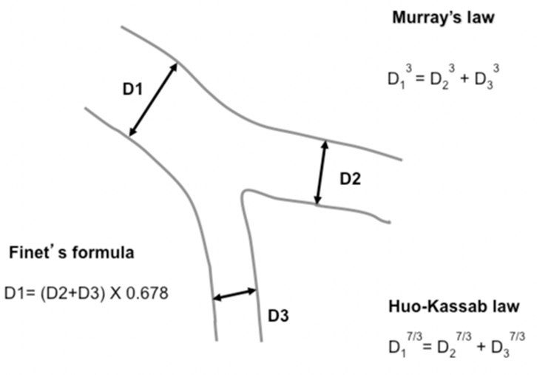

Figure 1: Murray's and Finet's Laws.
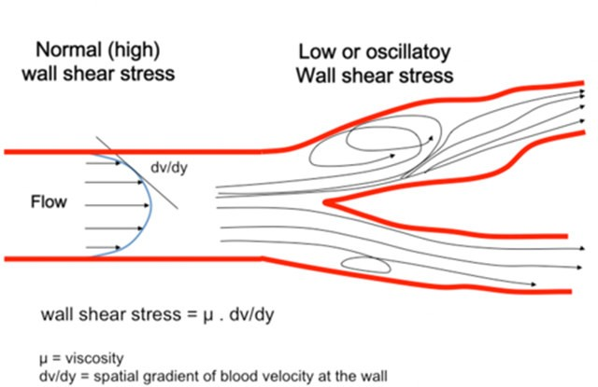

Figure 2: Shear Stress Differences at the Bifurcation Carina.

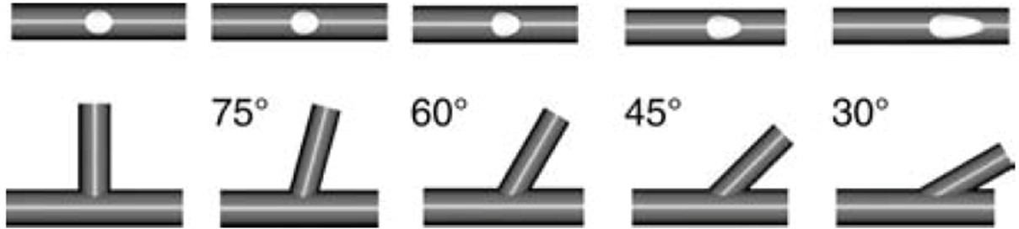
Figure 3: Impact of Bifurcation Angle on SB Ostium.

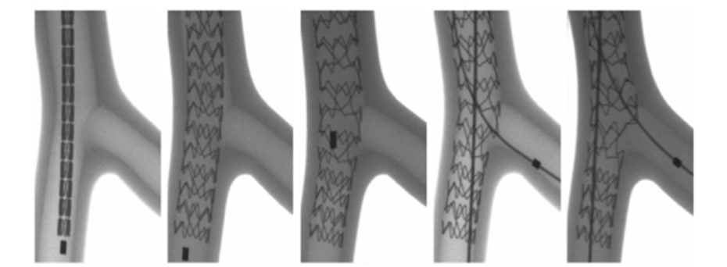

Figure 4: Proximal Optimization Technique (POT).
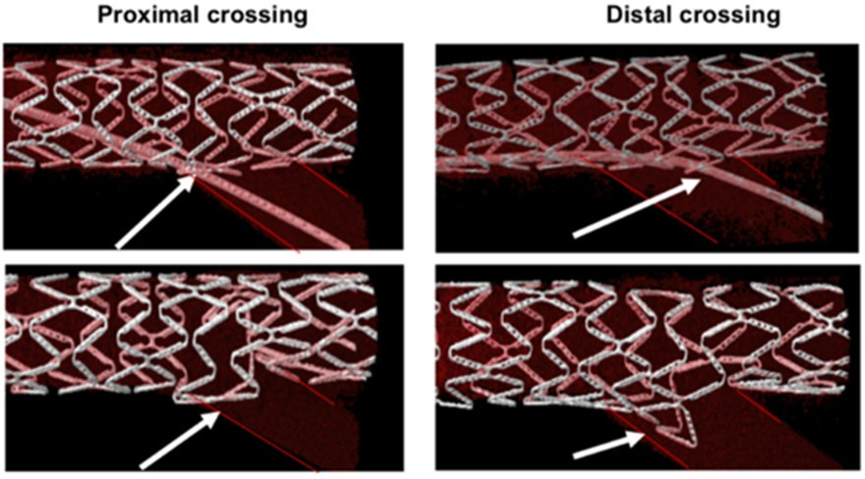

Figure 5: Proximal and Distal Rewiring.

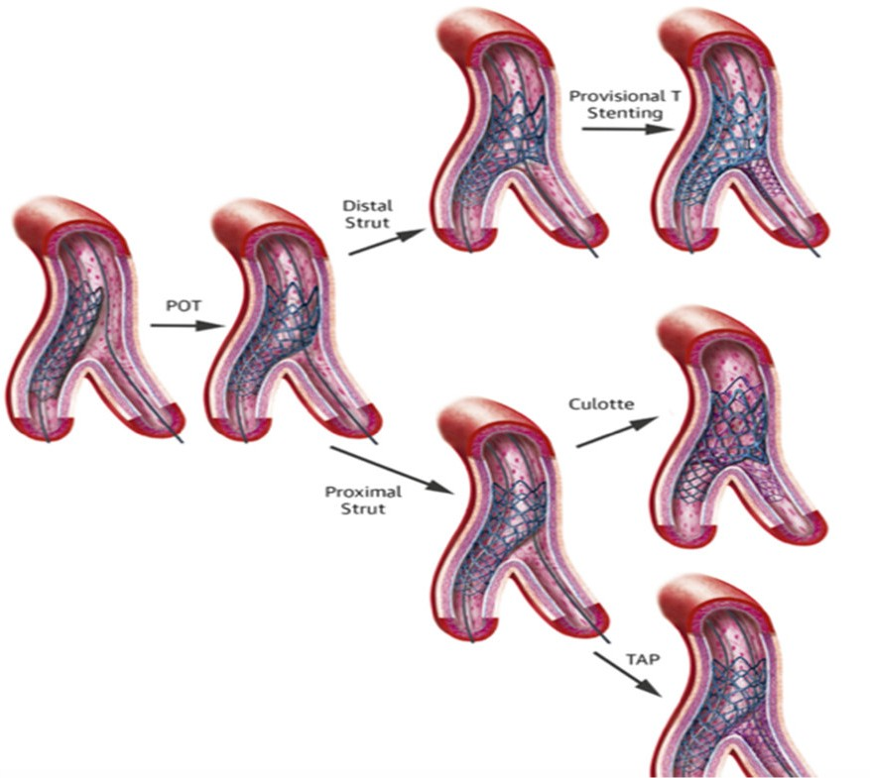

Figure 6. 1 to 2 stent techniques.

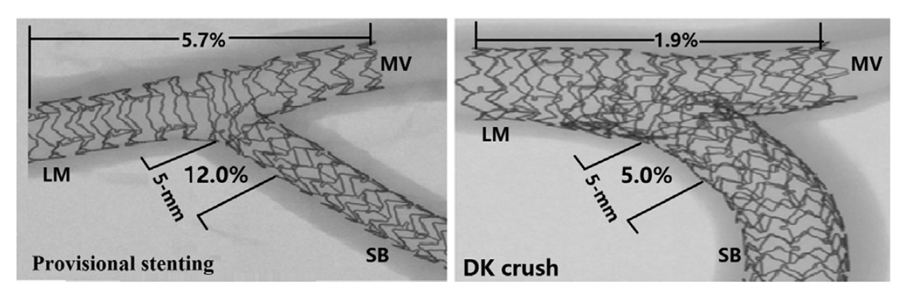
Figure 7. Incidence of restenosis between TAP and DK-Crush techniques.

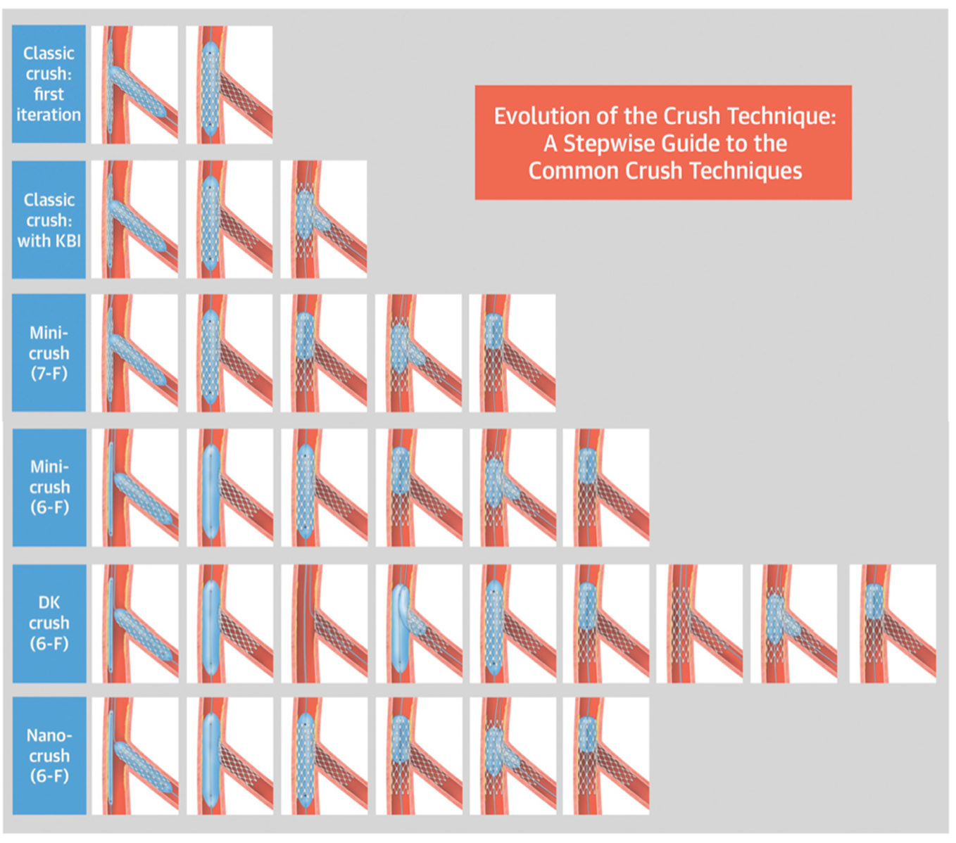
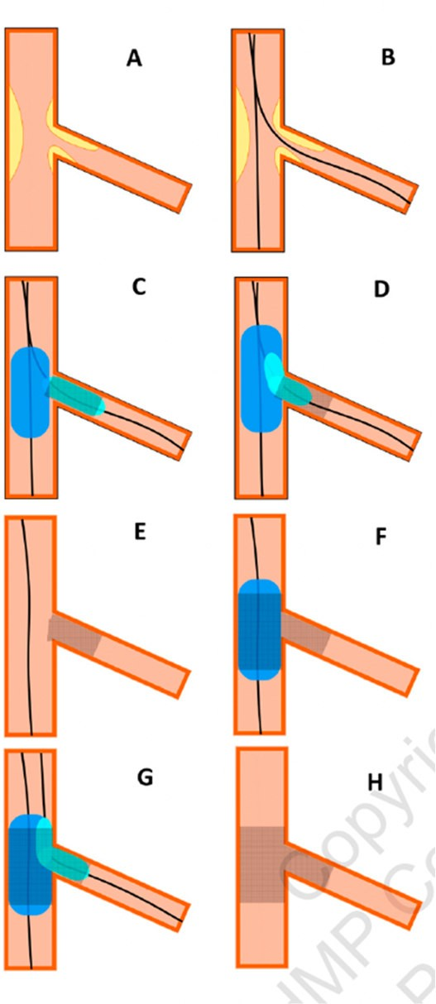
Figure 8. Evolution of "Crush" techniques.

Figure 9. Reverse-TAP technique.

